**IMPORTANT SQL QUESTION**

**==================================================================**

Q1: Write an SQL query to report the first name, last name, city, and state of each person in the Person table. If the address of a personId is not present in the Address table, report null instead.

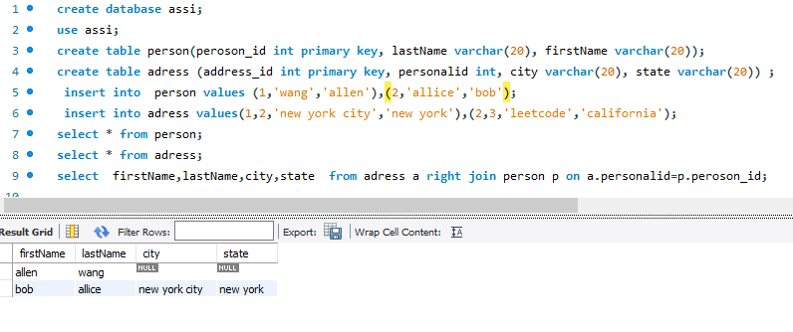

Q2: Write an SQL query to report all the duplicate emails.

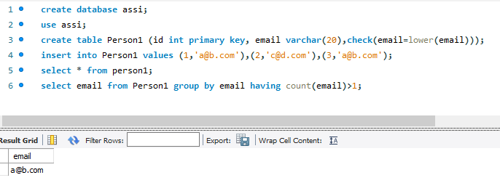

Q3. Write an SQL query to find the employees who are high earners in each of the departments.

